**Banqi Development Manual**

Contents

Introduction 1

Clone GitHub Repository 1

Quick-Start 2

Register 4

Login 4

Unregister 4

Exit 5

Logout 5

Create-Game 5

Open-Games 6

View-Profile 6

View-Invites 6

View-Sent-Invites 7

Show-Players 7

Clear 8

# Introduction

Banqi or Half Chess, also known as Dark Chess or Blind Chess, is a two-player Chinese board game played on a 4x8 grid, or half of the xiangqi (Chinese Chess) board. Most games last between ten and twenty minutes, but advanced games can go on for an hour or more. Banqi is a social game, usually played for fun rather than serious competition. A more formal version of the game may have evolved into Jungle (board game) and modern Luzhanqi.

This document will discuss how to properly download and run a java implementation of this game that our team (Generic Team Name) created.

# Clone GitHub Repository

A standard development folder structure is recommended. Development files can be set up as follows (Windows is assumed, but similar structure to Linux).

> C:

> cd \Users\user

> mkdir BanqiGame

> cd BanqiGame

> mkdir git-repos

> cd git-repos

> git clone https://github.com/Korysam15/cs414-f17-301-GenericTeamName.git

# Quick-Start

After pulling down the repository open up a terminal and change into the BanqiGame directory:

cd BanqiGame/git-repos/cs414-f17-301-GenericTeamName/P5

**NOTE** make sure to chmod the server.sh and client.sh:

chmod 777 server.sh

chmod 777 client.sh

Once in the P5 directory, proceed to run the server.sh by typing in the following command:

./server.sh

This will start to run a new server allowing clients to connect to.

Once the server has been started, create two new terminals and change into the BanqiGame directory. In each new terminal run the client.sh script:

./client.sh

Once the client.sh starts up you should see a screen similar to below:



For the second client, type in:

[test2@test.com](mailto:test2@test.com)

TEST2

test2

In the test console/terminal type in ‘create-game test2’. This will send a game invite to test2. Once this happens a popup will display asking if test2 will accept or reject the invite. Click on accept. This will then start a game between the two players.

If at any time you are lost, type in ‘help’ in the terminal and it will display the following:

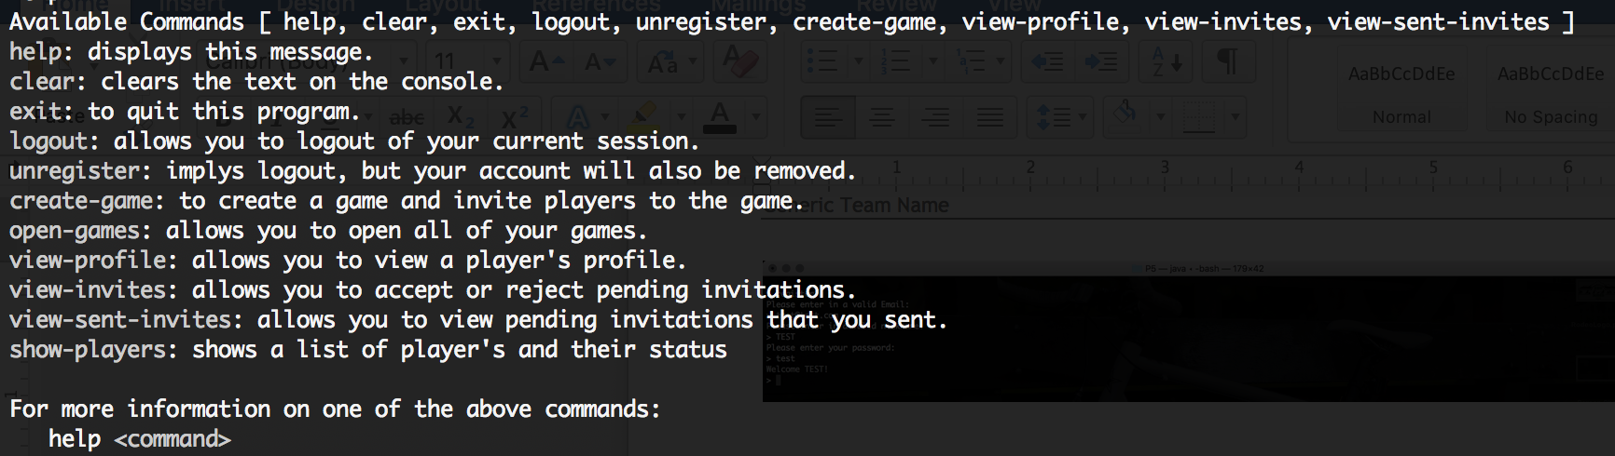

# Register

After a client has been started, type in the console ‘register’. This will then prompt you to enter in an email, password, and nickname.

Enter in a valid email, password, and nickname.

EX:

[test@test.com](mailto:test@test.com)

TEST

test

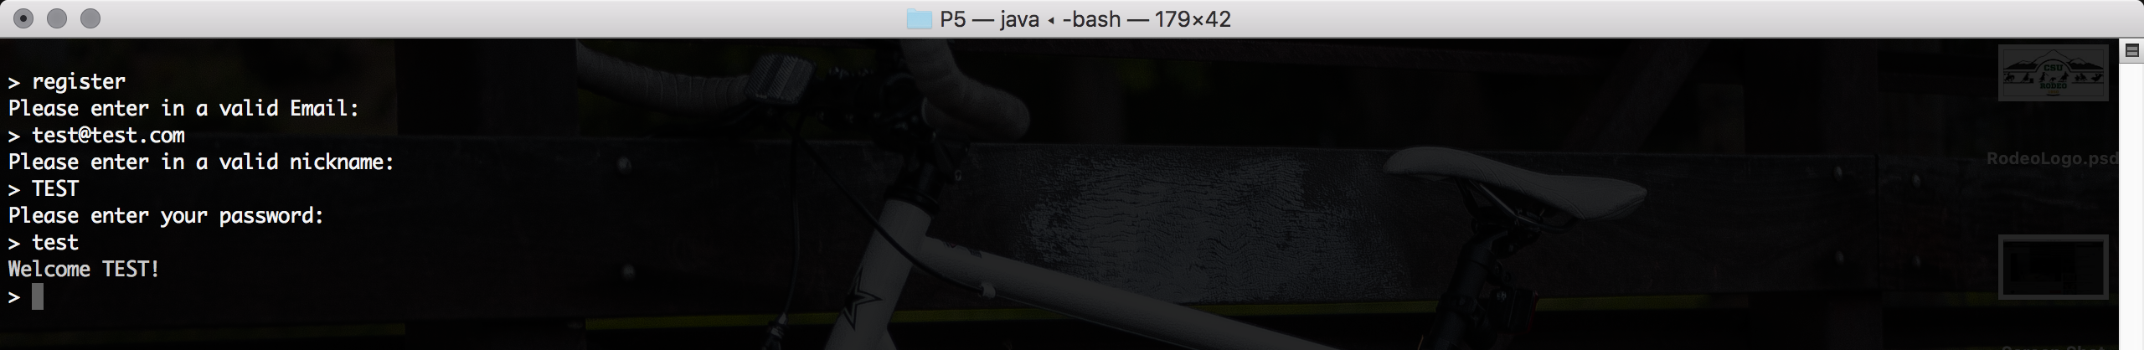

# Login

After a client has been started and a user has already been registered to the system, type in the console ‘login’. This will then prompt you to enter in a valid email and password.

Enter in a valid email and password

EX:

[test@test.com](mailto:test@test.com)

test

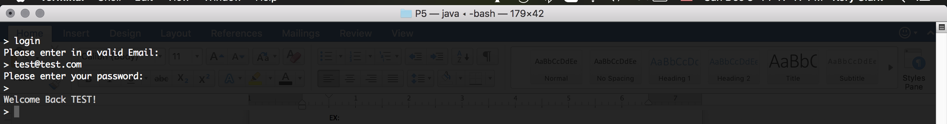

# Unregister

After a client has been started and logged in, type in the console ‘unregister’. The console will then print out the following message, “Your account will be deleted if you unregister. Are you sure you want to unregister and remove your account?

Type 'yes' if you are sure you want to delete your account, otherwise click enter.”

In order to successfully unregister type in ‘yes’.

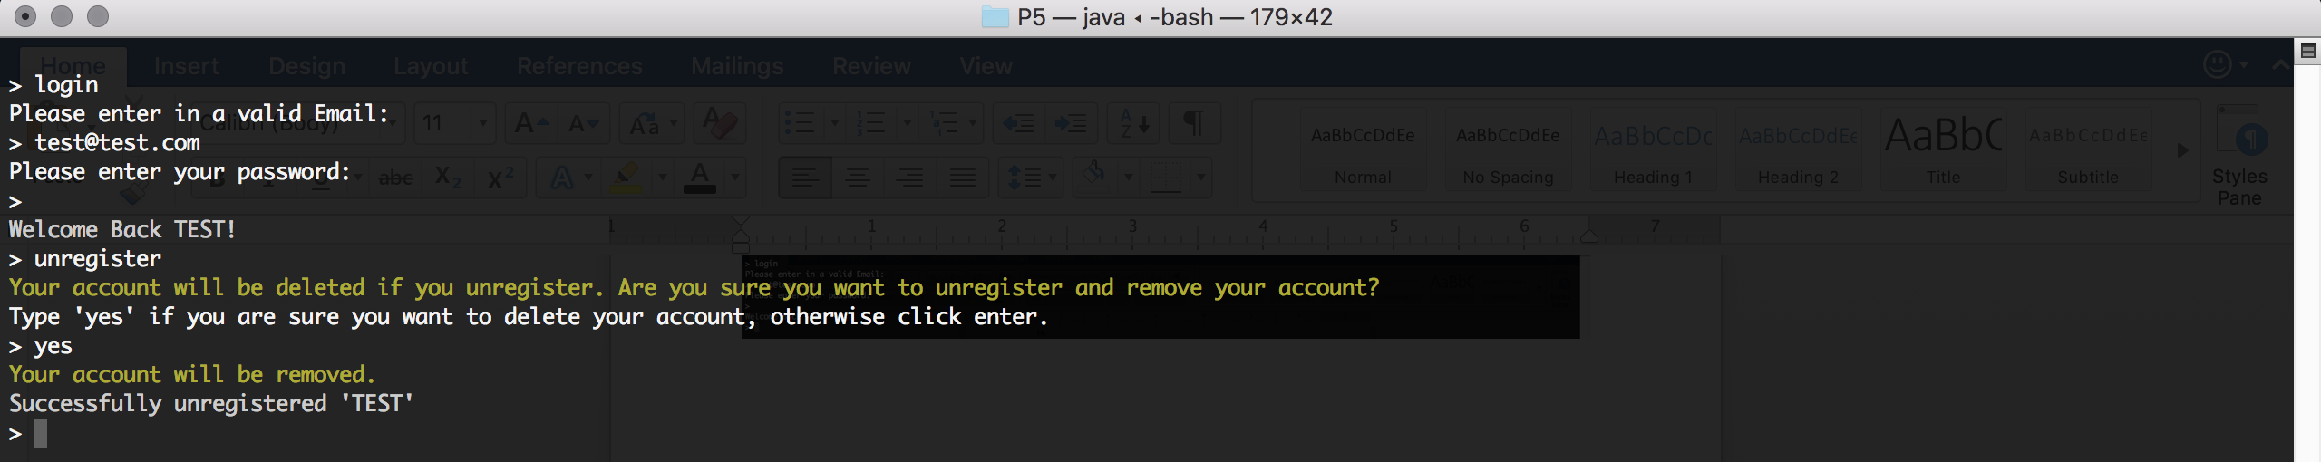

# Exit

After a client has been started and logged in, type in the console ‘exit’. This will disconnect you from the server and will bring you back to your main console.



# Logout

After a client has been started and logged in, type in the console ‘logout’. The program will then take you back to the register/login screen.



# Create-Game

After a client has been started and logged in, type in the console ‘create-game’. This will then prompt you for a username to send to. It will continue prompting you for usernames until you don’t enter anything and just click enter. After you have entered the username(s) to send an invite to, the console will prompt you with what message you would like to send them. Once entering in a message it will send the invite and the invited user will receive the invite.

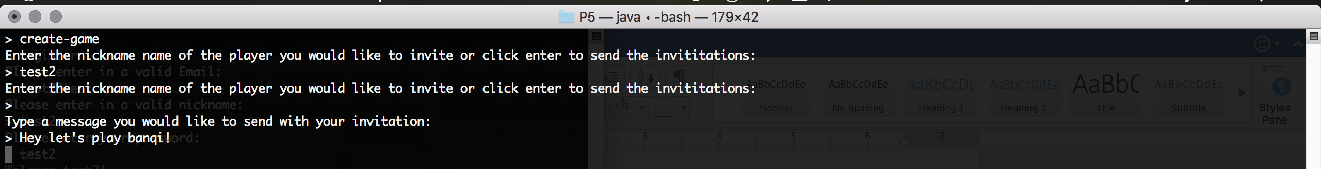

# Open-Games

After a client has been started, logged in, and has started a game you may view the games that user has not completed. For example, if a user has started 5 games and has not finished those five games then the ‘open-games’ command will open those games to complete and finish playing.



If a plyer were to login, this message will display with the number of active games they have.

# View-Profile

After a client has been started and logged in, they can view any players profile included their own. Type in the console, ‘view-profile’ and click enter when it prompts for a username. It will then display their profile similar to below:

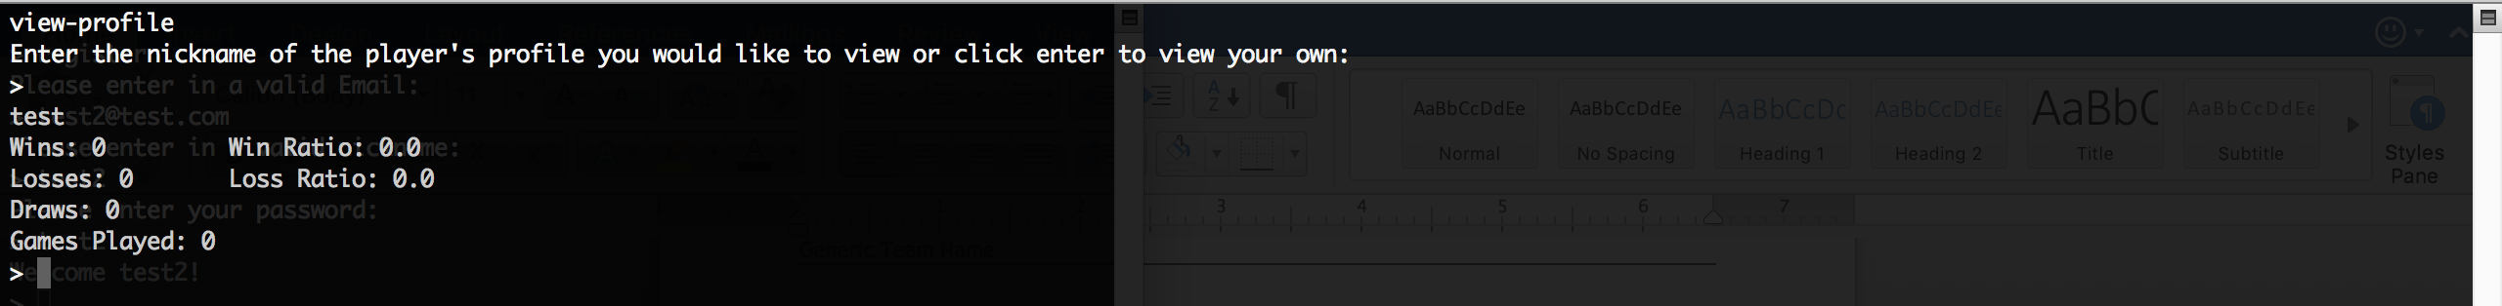

# View-Invites

After a client has been started and logged in, they can view the invites they have received by typing in the console, ‘view-invites’. If there aren’t any the console will display the message, “You do not have any pending invitations”. If they do have invitations this command will prompt a new java window to open and will ask the user to accept or reject the invitation.

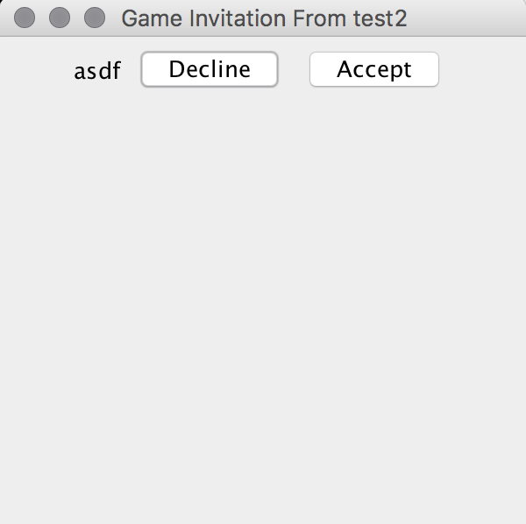

# View-Sent-Invites

After a client has been started and logged in, they can view the invites they have sent by typing in the console, ‘view-sent-invites’. If they do have invitations a list of invites will display on the console similar to below:

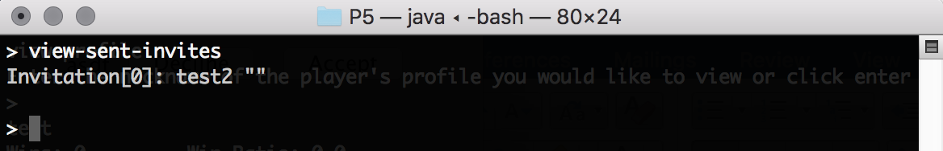

# Show-Players

After a client has been started and logged in, they can view the online/offline players on the game server. Type in the console ‘show-players’ and a list of online/offline players will display to the console similar to below:

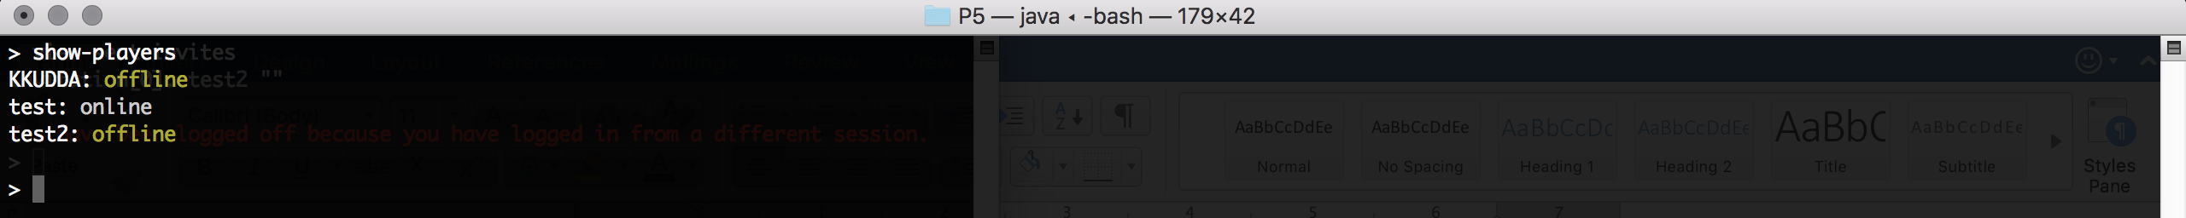

# Clear

If at any time you want to clear the console of messages type in ‘clear’ and the console will clear.